Kenya February 2019
A team of 10 people including 4 local bellringers (9 from around the greater Swindon area and 1 from Edinburgh) travelled to Nakuru, Kenya to volunteer in Melon Mission School. We had spent about 9 months preparing for the trip and collecting ideas, crafts and donations to allow us to enhance the lives of the children while we were there.
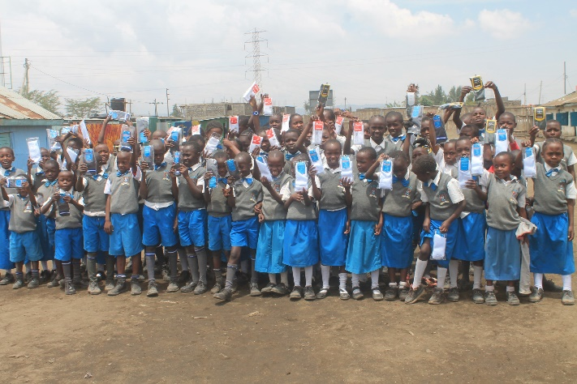
Day 1 – overnight travel from London to Nairobi and on to Nakuru
Day 2 - allowed us to meet the children and acclimatise to the school environment. Both staff and children were very welcoming and we felt our time with them would be well spent. We also toured the new school, recently opened for the new term in January 2019 but still a long way from being finished. This included the new toilet block sponsored by four groups from the UK. In the previous school there were three soil toilets between 400+ children. In the new school there are 15 toilets for boys, girls and teachers with flushing water and hand-washing facilities.
Day 3 - was Saturday and we arranged a sports day for the children with activities like volley ball, relay races, skipping, rounders etc. This enabled us to get to know the children better and chat to the staff and head teacher. We visited a Tea/Coffee plantation in the afternoon and were briefed on farming methods around the volocano rich soil near the Menengai crater.
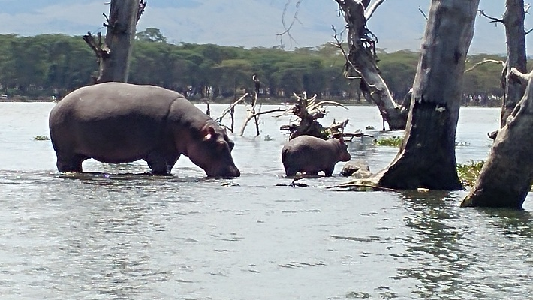
Day 4 – took us to Lake Naivasha on a water safari to see a wide range of wildlife – Hippos, Giraffe, Zebras and many kinds of bird, flamingos, pelicans, secretary birds, large kingfisher, eagles, Ibis etc. We felt quite jetlagged today and spent the afternoon and evening recovering and preparing for the week ahead.
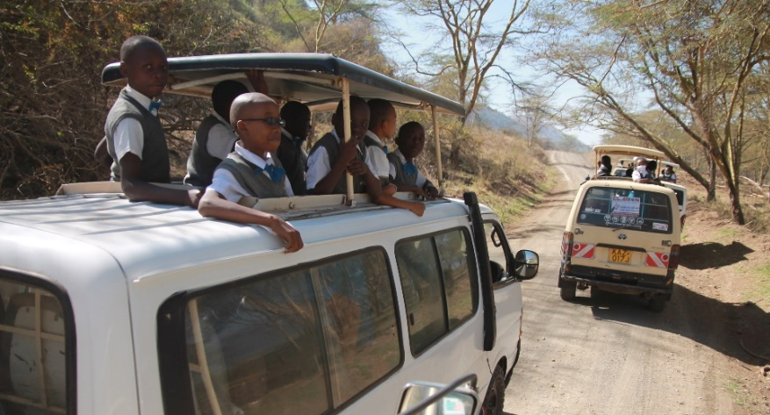
Days 5 -8 – were all spent working at the school. During this time we did a range of activities from digging out and repairing sewers and guttering to collect rainwater in a new collection tank we supplied for the school, crafts with the children, taking lessons in the school, providing additional food etc. On day 7, 38 children were able to go on a half-day safari using donations from a range of our supporters and have lunch out in a local restaurant provided by Lydiard Millicent Luncheon Club. Although the children live less than a mile from one of the great national parks of Kenya none of them have seen the amazing wildlife and this enabled them to see just what their country has to offer and potential jobs form themselves in the future. I also taught a recorder lesson to 17-18 children each day with the aim of being able to play the Kenyan National Anthem so they can do this for important events and National days. They really enjoyed this and learned very quickly. The head teacher Michael was keen for them to do this and promised to practice regularly.
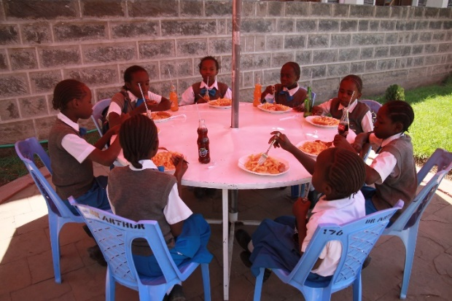
Day 8 allowed each child to be given shoes, socks or an item of clothing. It was both heart-breaking and gratifying to be able to provide something for those who have so little. We were also able to give each nursery child a dressing up outfit (the best received gift of all – all their Christmases come true at once) or a small toy. The infant and junior school children all got a balloon or small toy or notebook, or small ball and a sweet or lollipop. Day 7 – we visited several children in their homes, very poor and quite a cultural shock for each of the group. We took a gift of a lidded bucket filled with rice, flour, maize, cooking oil, soap and a treat packet of biscuits to each family.
Days 5-8 – each day we provided additional food for every child – an egg, piece of fruit, bread roll etc which they had in addition to their usual food. Melon Mission school is unusual in Kenya as they provide two meals each day for the children – porridge mid-morning and a cooked lunch. For a lot of the children this is the only food they get.
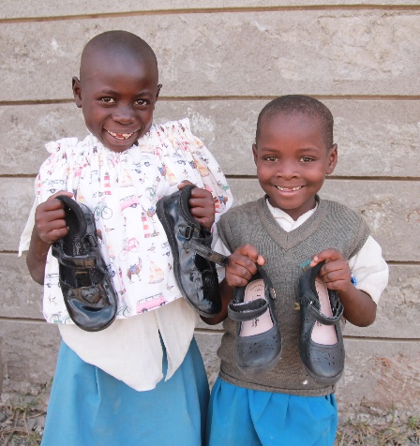
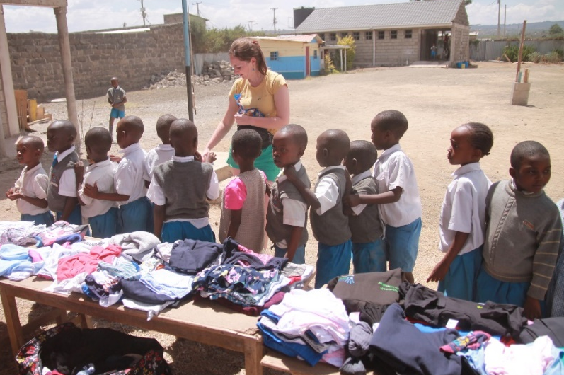
Days 9-11 were spent visiting the Masai Mara to see amazing wildlife and then touch base briefly with the Melon Mission team back in Nakuru to see some of the additional equipment our donations had been able to buy for the school. We were able to supply a range of books, educational games, classroom resources including a large stationery pack for each of the teachers at the school (pens, chalk, colour pencils, writing paper, notelets, scissors, staplers etc). The books and games will be used to start a library for the children to use. We were also able to buy 32 mattresses for the nursery children to use as they have a nap after lunch. These were specially made for the school and are waterproof so they don’t soak up damp from the ground during the rainy season and wipeable if the small children have an accident. When we went to the school at the start of the week each of the little ones were sleeping with their head on the desk so it will be a lot more comfortable for them and also the school is obliged to supply these to meet government recommendations.
Day 12 – We travelled back to Nairobi, had a short visit to the David Sheldrick Elephant sanctuary to hear about their conservation work and then on to the airport to travel back to the UK.
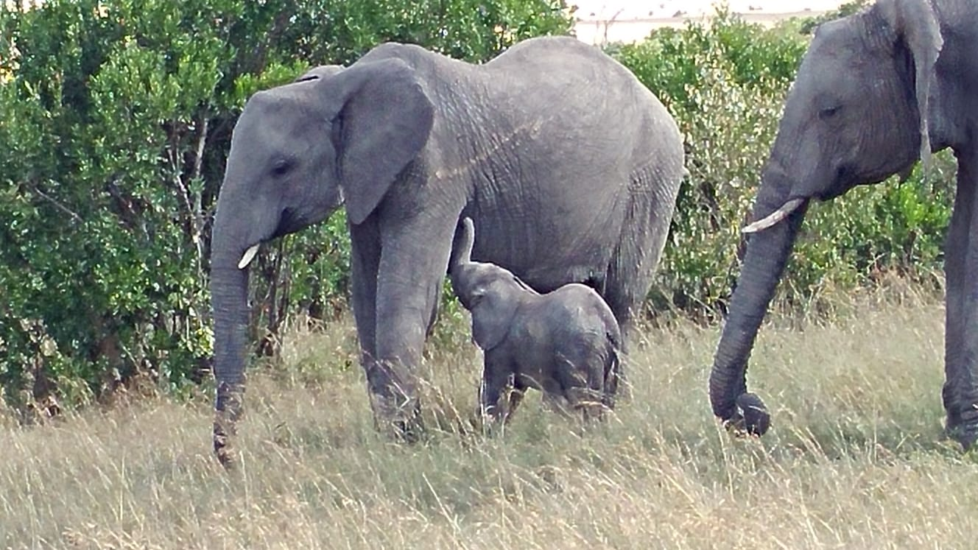
An exhausting but extremely interesting visit to the lovely country of Kenya. We were able to provide a lot for the school and children in our time there and definitely leave them better resourced.

http://www.melonmission.org/
https://www.sheldrickwildlifetrust.org/

